

Dds
Newington Community Primary School
Princess Margaret Avenue, Ramsgate, Kent. CT12 6HX
Tel: (01843) 593412 Fax: (01843) 850323
Headteacher: Miss Hannah Tudor
E-mail: headteacher@newington-ramsgate.kent.sch.uk
Ambition, Achievement, Aspiration

Monday 8th December 2025



Dear Parents and Carers
We have been enjoying a wonderfully festive Term 2 and the school is well and truly in the Christmas spirit. It has been wonderful to see the school transform in to a winter wonderland as the staff, and parents have worked tirelessly to ensure that the children make fantastic Christmas memories to cherish. We cannot thank our parents and school community enough for all the support they have shown us this term. This newsletter celebrates some of our Christmas events and provides some key information about the end of Term 2.
This term……
Term Dates
The last day of Term 2 will be Friday 19th December 2025. School will close at the earlier time of 2.15pm. There will be no Wraparound provision on the last day. Term 3 will start on Monday 5th January at the usual time.
Christmas Celebrations
The school has well and truly in the Christmas spirit. Thank you to all of the parents who came along to our hoop making sessions in school. The children loved having you there and the hoops, a well know Newington tradition, look absolutely wonderful. They always mark the start of Christmas at our school.
Key Stage 2 Christmas Performance
The children performed this brilliantly and it has been such a super start to “Performance Week” at Newington. Unfortunately, it has come to our attention that some families have been taking screen shots of booking confirmations and sharing them with other family members. This led to the hall being very crowded for the first performance. This is a significant Health and Safety issue and also affects the quality of the experience for the audience as a whole. Naturally parents were frustrated as many of them had booked and were then affected by a small number of families who came along without a booking. PLEASE do not do this – it causes significant stress for school staff, increases pressure for the children who had to perform again unplanned and is really unfair on parents who do book and do what the school asks of them.
Moving forward, only families who have booked via the booking system will be allowed to access performances at the school. It really will be “if your name’s not down, you’re not coming in” – sad times but what happened this morning was unfair on the children and cannot happen again.
Make A Wish
Every child has made a decoration for the tree this year. We challenged all children to make a wish and write it down. We have loved reading our children’s wishes including; spending time with grandparents, an end to homelessness over the festive period, company for everyone who feels lonely and chocolate for breakfast. The tree looks stunning!
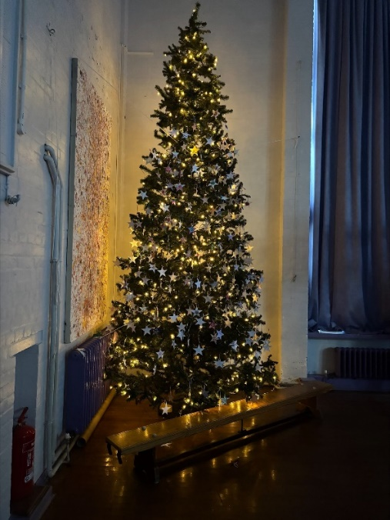
Advent Christmas Stories
The staff have loved putting together the Advent of Christmas stories. Every day, throughout Advent a different member of staff shares a Christmas story. The videos are available through our Facebook page. If you haven’t caught up with them, head to our Facebook page to take a look.
Clubs
This week will be the last week for clubs. There will be no clubs running next week as it is the final week of term.
Christmas Jumpers
Thursday 11th December is Christmas Jumper Day in school. We recognise that children love to wear their Christmas jumpers and they can be expensive, so children are invited to replace their school jumper with a Christmas jumper for the final week of term. We are going to have a “Christmas Jumper Week”.
Christmas Parties
These have been arranged in year groups. Please message your child’s teacher if you are unsure of the date of your child’s Christmas party. Look out for information via see-saw.
Carols by Candlelight
This year’s Carols by Candlelight will be held on Wednesday 17th December at 4pm. This year the event will be held at St Christopher’s Church. It is a lovely community event and everyone’s invited. There is no limit to numbers so please come along and enjoy a festive sing along with Mr Eldred, school staff and our wonderful choir.

Christmas Raffle
We will be selling raffle tickets on the KS 2 playground ready for our Christmas raffle draw next week. There are some fabulous prizes so please head over to the KS 2 playground to get your raffle tickets. Tickets will also be on sale at the end of the performances this week.
Looking ahead to next term……
New Year R Applications
A reminder to all parents of children who wish to join our school in September 2025. The final day for submitting an application is Thursday 15th January 2026. For more information, please look at the following website: https://www.kent.gov.uk/education-and-children/schools/school-places/primary-school-places
The final newsletter of the school term will be sent out on Friday 19th December. This newsletter will include all of the details needed for Term 3.

With very best wishes

Hannah Tudor
Headteacher

