
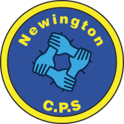
Dds
Newington Community Primary School
Princess Margaret Avenue, Ramsgate, Kent. CT12 6HX
Tel: (01843) 593412 Fax: (01843) 850323
Headteacher: Miss Hannah Tudor
E-mail: headteacher@newington-ramsgate.kent.sch.uk
Ambition, Achievement, Aspiration


Friday 19th December 2025

Dear Parents and Carers
Over the passed three weeks, we have held three discos, wrapped 700 Christmas presents for the children, hosted 4 nativity plays, 3 KS 2 concerts, a carol service in the church, held 7 Christmas parties, cooked and served over 1400 Christmas dinners, held a raffle, worn our Christmas jumpers and hosted numerous visits from Father Christmas himself in our very own grotto. It has been a wonderful time to be in school and despite many festive events, the staff have remained committed to ensuring that all of our children get the very best of what we can offer in classrooms.
Christmas at Newington
“Carols by Candlelight”
Thank you to all of the families who attended. Mr Eldred and Mrs Groom got everyone singing and it was a fabulous festive event. Thank you to Mr Eldred for encouraging us all to sing so beautifully and to our children who made the event extra special. The choir have been busy spreading festive cheer around the town. On Sunday 21st December they will be appearing at Carols in the Park at Ellington Park to lead some of the festivities. We would like to encourage as many families as possible to head down and get involved. The event starts at 6pm with drinks being served from 5pm. This really is a wonderful family event – perfect for getting everyone in the Christmas spirit!
Christmas Dinner
A huge thank you to our fabulous kitchen team who have provided Christmas dinner for all of our children, and their families this week. It was wonderful to open our doors to parents and grandparents and we would like to thank everyone who attended – we understand that it is a busy time of year. Special recognition goes to the NCPS kitchen staff though – they are truly brilliant and I really don’t know how they do it! But they do and they do it brilliantly!
Performance Videos
We know that the year group performances are a highlight of the year for many of you. We also recognise that some of you cannot get in to school at this very busy time of year! Mr Eldred and Mrs Groom have been busy filming and editing each one of the performances so that everyone can watch at their leisure. Links will be made available for these videos via see-saw.
Staff Goodbyes

This week we said goodbye to Mrs Shallcross who has decided to move on from Newington to a new adventure. Mrs Shallcross will be the Inclusion Lead in a school just outside of Thanet. I know that you will all join with me in wishing her the very best in her new career and to thank her for the contribution that she has made to life at Newington.

Staff Hellos

A big welcome to the team to Mr B who will be taking over teaching in Libra class. Mr B has been enjoying the Christmas cheer at Newington, getting to know the children and really learning about life at the school. I know that you will join with us in welcoming Mr B to the team.

Staff Thanks
A special thank you to all of the staff here at the school. They work so hard to make sure that the children have memories that they can treasure forever. The staff who have created and rehearsed the year group plays, provided parties for the children and found innovative and new designs for class Christmas hoops. To Mr Eldred and Mrs Groom who provided all of the musical fun of Christmas whilst also ensuring that school performances and our Advent Christmas stories are edited and can be shared at home with family who were unable to join us in person. To the welfare team who have been working in partnership with local groups, including Chartwell House Care Home and The Salvation Army, to ensure that all of our families have a great Christmas. The office staff who have made sure all of the organisation has been in place for all of our Christmas events. The site team who have decorated the school, put up trees and hoops, built Santa’s grotto and put chairs out and collected them in for all of our performances. To Miss Mack for producing our school Christmas cards, endless decorations and ensuring that all of the children’s art work is displayed brilliantly around the school. To the kitchen team and Midday Supervisors who have provided Christmas dinners, buffets, sandwiches and whatever has been required throughout our build up to Christmas. And lastly, a big special thank you to the cleaning team who have tidied up the school at the end of each day; hoovered up the glitter, wiped away the paint and the glue, swept up the crumbs from the Christmas party so that the school was ready to do it all again the next day. They are a staff team to be truly proud of.

New Year – New Start!



As we get ready to welcome in 2026, here is some key information for the coming term.
Clubs – Term 3 and 4
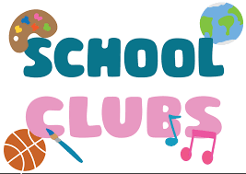
Term 3 and 4 clubs will be starting in week 2 (week beginning Monday 12th January 2026). They automatically run for terms 3 and 4.
Clubs will run Monday – Thursday. They start at 3.20pm and finish at 4.20pm. Children will need to be picked up by an adult on the top tarmac via the gate. Children will not be allowed to walk home on their own after a club.
Key Dates for Parents

Here is an overview of the key dates for Term 3.

What’s for Lunch?

Here is a copy of our lunch menu. We will start on Week 1 of the menu for the first week back. Our wonderful kitchen team have updated the pudding menu so that children enjoy a warm pudding during the colder months.

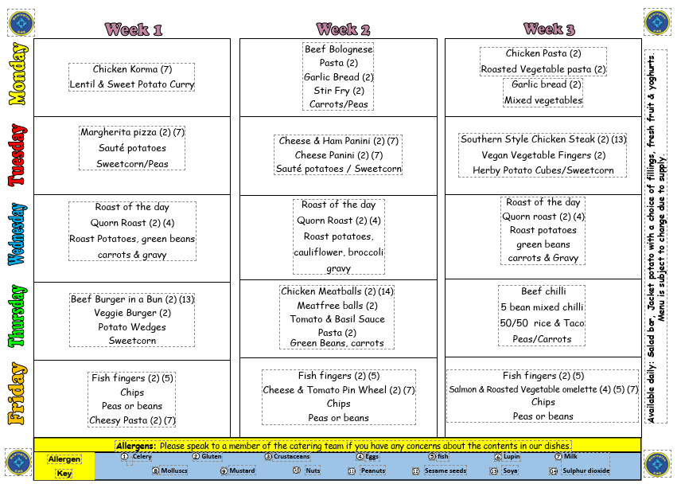

What’s for pudding?

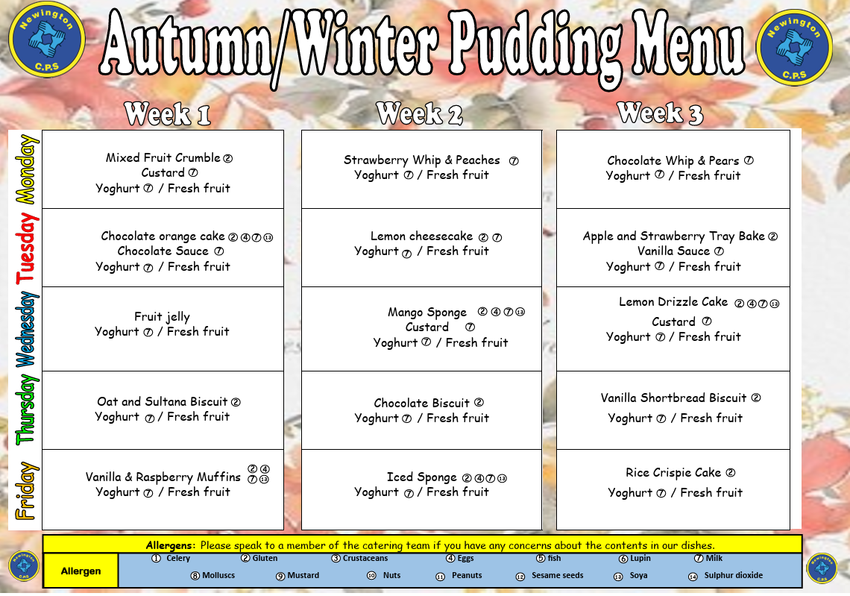
A final Christmas Message

Thank you all for your support as we have come to the end of term – we really do appreciate it! On behalf of the staff and Governors at NCPS, we would like to wish all of the children and their families a very Happy Christmas and a wonderful start to the New Year. Stay safe and we look forward to welcoming you back to school for the start of Term 3 on Monday 5th January 2026 when doors will open at 7.45am for Breakfast Club!



