

Ambition, Achievement, Aspiration
Newington Community Primary School
Princess Margaret Avenue, Ramsgate, Kent. CT12 6HX
Tel: (01843) 593412 Fax: (01843) 850323
Headteacher: Miss Hannah Tudor
E-mail: headteacher@newington-ramsgate.kent.sch.uk
Dds

Friday 1st May 2026
Dear Parents and Carers
Welcome back to the start of the summer terms at Newington. We all hope you enjoyed the Easter break. The children have returned ready for learning all the excitement that Term 5 brings.

This week we said goodbye to a member of our Senior Leadership Team. Mrs Gower has been a vital part of our school community, ensuring that our youngest children get off to the best possible start with us at Newington. Mrs Gower has lead the Nursery and Reception teams ensuring that provision is fun, engaging and challenging resulting in great progress. I am sure that you will join me in thanking Mrs Gower for all of her hard work and commitment to the school. We all wish her the very best for the future. THANK YOU MRS GOWER!!
Term 5 - Paddington


The school is already being taken over by a little bear in a red hat. Last week, Year 1 travelled up to London to visit The Paddington Experience. The day was a huge success and we have received an email from the staff at the venue saying how well behaved the children were and that we would be welcome back anytime.
This week, our three Reception classes enjoyed their trip to Wildwood. Due to the fantastic behaviour of the children and the organisation of the staff, the day ran brilliantly with everyone enjoying the day. What a great experience for some of our youngest learners.
Similarly, Years 4 and 6 travelled to London to the Savoy Theatre to watch Paddington the Musical yesterday. The children’s behaviour was EXCEPTIONAL and was commented on by so many of the theatre staff. A wonderful day for us all and definitely one to remember!
Other key dates for parents relating to Paddington are:
Thursday 7th May - Years 3 and 5 Visit to Paddington
Thursday 14th May - Year 2 Visit to Paddington
Thursday 21st May – Whole school performance 9.30am and 1.30pm
Friday 22nd May – Whole school performance 9.30am and 1.30pm

Thrive Ambassadors in Action
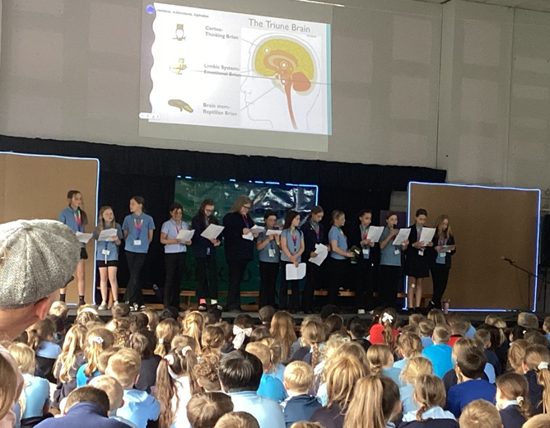
There was a buzz of excitement in the hall this week as we officially celebrated the launch of our brand-new Thrive Ambassadors! After weeks of hard work and preparation, 15 of our Year 6 pupils have stepped up to take on this important leadership role within our school community.
To kick things off, our 15 ambassadors took centre stage to lead an inspiring assembly for Key Stage 2. With confidence and clarity, they shared insights from their recent Thrive Training, explaining the science of wellbeing and the importance of emotional support.
The ambassadors spoke about how they have learned to listen, offer a helping hand, and ensure that every child feels safe and happy during the school day. It wasn't just a presentation; it was a promise to their peers that they are here to support, encourage, and include everyone.
The ambassadors aren't just talking the talk—they are already busy preparing to make our lunchtimes more vibrant and inclusive! Starting next week, look out for our Thrive team on the playground, where they will be hosting a wide range of activities designed to bring out the best in everyone. Activities such as arts and crafts, story time, parachute games, giant Jenga and much more will be on offer.
Whether you’re looking for a moment of calm or a high-energy game, there is something for everyone.
The Thrive Ambassador program is all about building a culture of kindness and resilience. By having children support children, we are strengthening our school's heart.
"We want everyone to feel like they have a friend on the playground," said one of our new ambassadors. "Sometimes a quick game of Jenga or a chat is all someone needs to have a better day."
A huge congratulations to our 15 pioneers! We can’t wait to see the positive impact you’ll continue to have on our school. Keep an eye out for those rainbow lanyards during lunch—your ambassadors are ready to play!
Intergenerational Day 2026
You may have seen in the local press that our amazing choir have been out and about spreading good cheer in the local community. This time, they travelled to Shottendane Care Home in Margate to mark Intergenerational Day. We really value the power of intergenerational relationships and the children were fantastic ambassadors for our school, singing a whole range of Newington classics as well as preparing a card that they would gift to the residents there. Thank you to Mr Eldred and Mrs Groom for making it all happen.
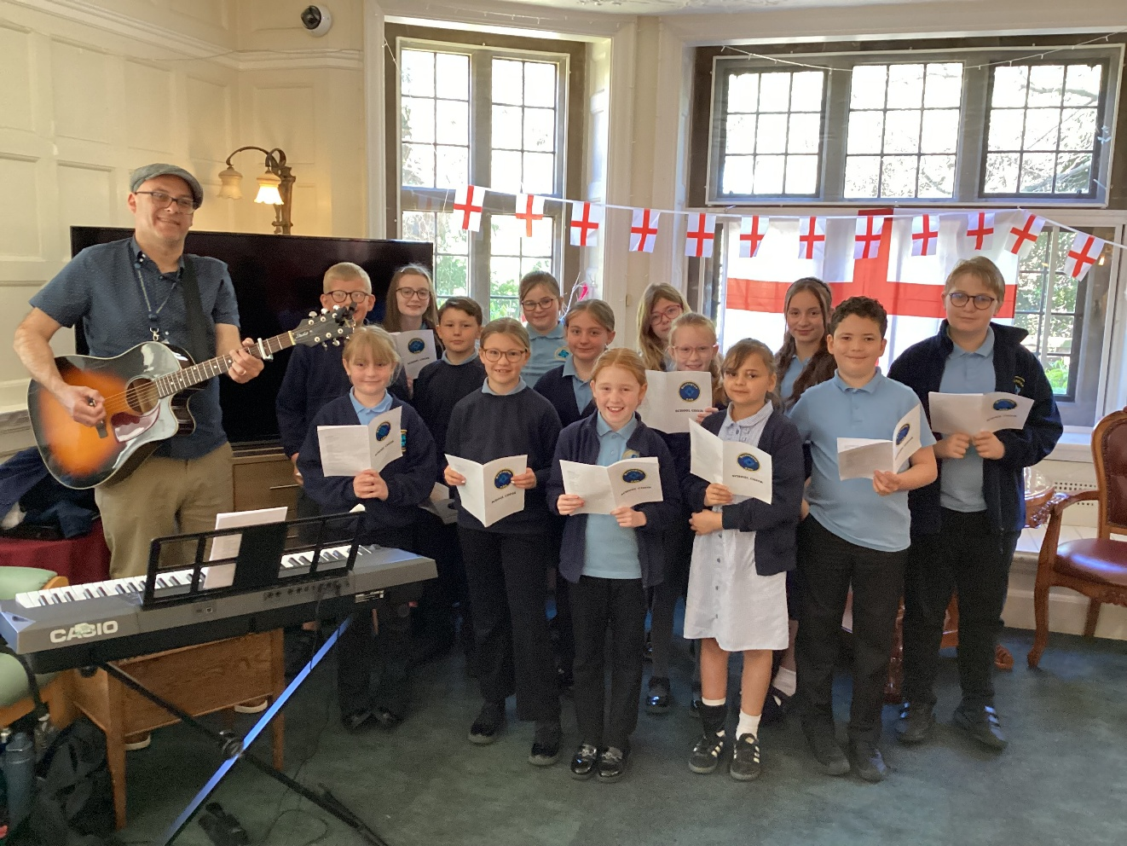

Year 2 – “How Plants Grow!”

Year 2 had a great time planting flowers, bulbs, seedlings and seeds as part of their Science topic “How Plants Grow”. We are going to look after our plants, understand what they need and observe how they change.
Archers Low Nursery kindly gifted the year group the plants, bulbs, seeds and vegetable seedlings.
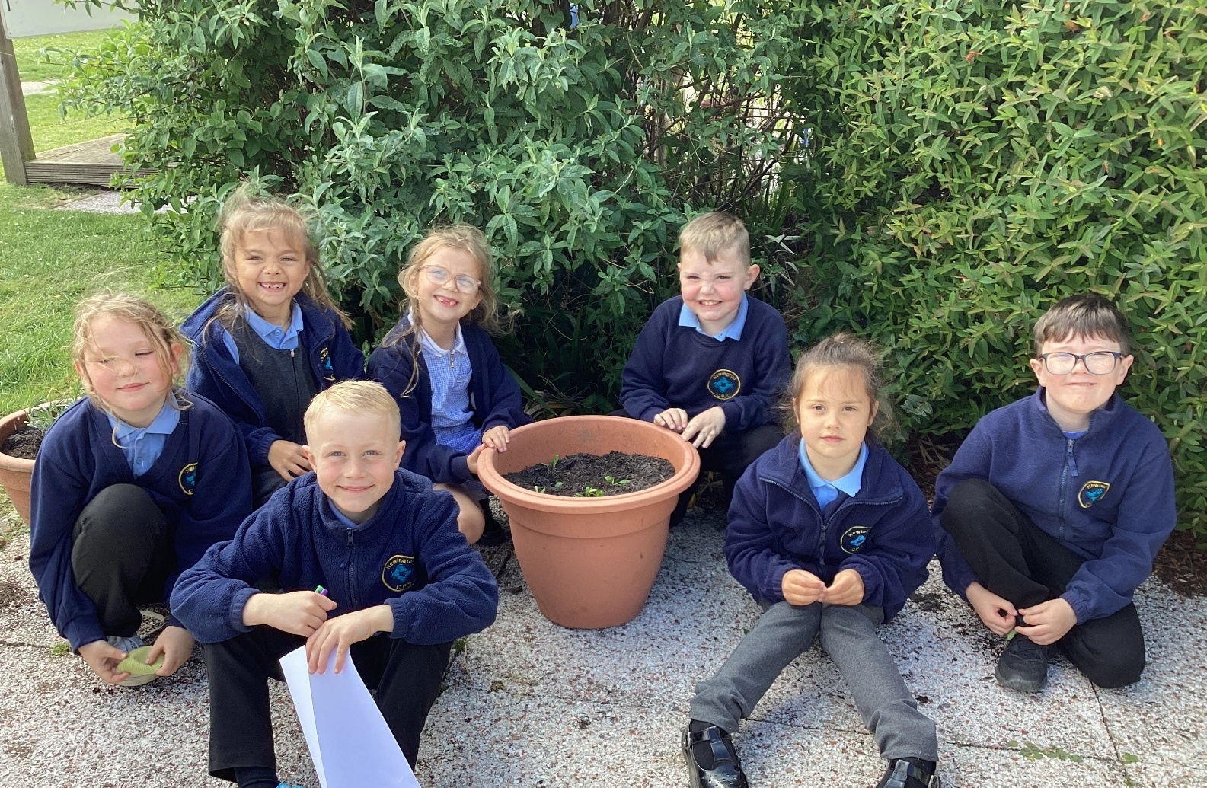
Lunchtimes at Newington
We’ve had some fabulous additions to lunchtime play on the KS2 playground this week. Thank you to the Junior Leadership Team for putting forward such fabulous suggestions for our lunchtime play. We’re also awaiting our BRICKBOX delivery, with Lego arriving by the kilogram ready for more building masterpieces!
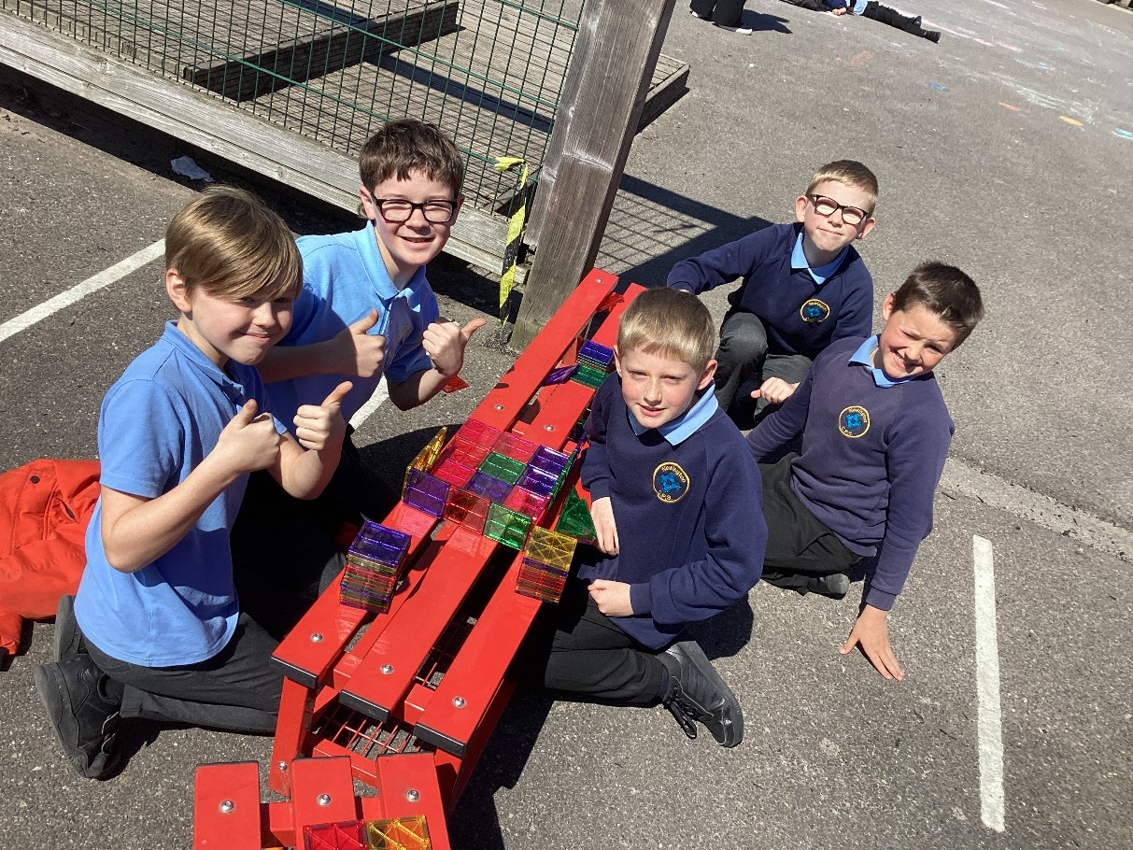
Chess Champs!

Can you help us? We have introduced a chess area on our KS2 playground, and it certainly is popular! Do you have any unused chess sets at home you would be willing to donate to us? Our Chess Champs would be so grateful!
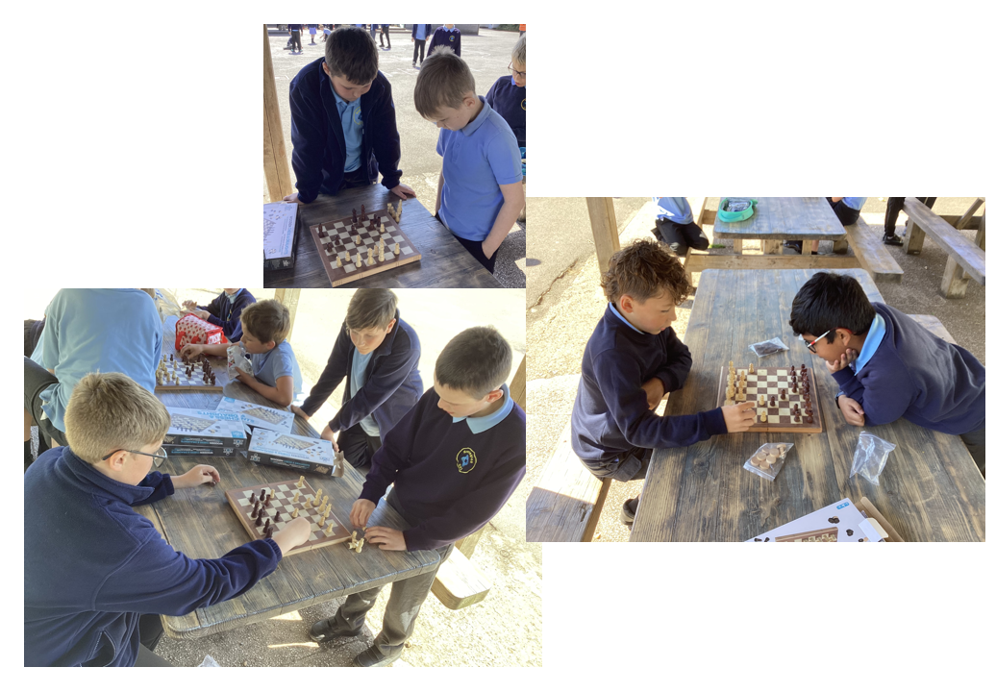
Bracelet Buddies!

Highly requested by KS2 children! A calm space for loom bands and bracelet making. Thank you to our Year 6 volunteers who have given up their own time to set this up so brilliantly. It’s been wonderful to hear you advertise this on the playground and encourage everyone to join you!
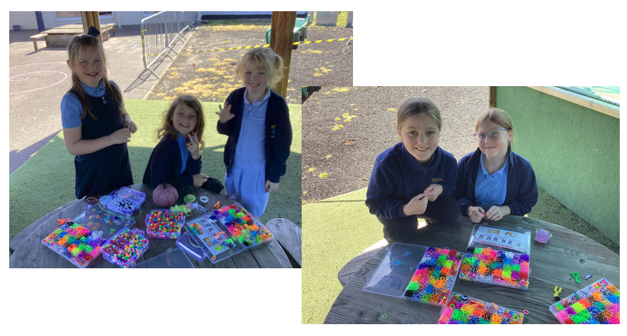
There is so much going on at lunchtimes on the KS 2 playground. It has been great to get the children’s ideas of what they would like to play when they are outside. Thank you to Mrs Smith, our playground buddies and Thrive Ambassadors for all their hard work.
Future Events
Sir David Attenborough’s 100th Birthday Celebrations
On Friday 8th May, we will be celebrating a truly monumental milestone: the 100th birthday of Sir David Attenborough. As a hero of conservation and a voice for our planet, we want to honor his century of work with a day dedicated to the wonders of the natural world.
To mark the occasion, pupils are invited to wear party clothes or, in true Attenborough fashion, dress up as an explorer or their favourite animal. We will be hosting a Street Party lunch to celebrate Sir David’s legacy. The school will provide a packed lunch for all children to enjoy during our outdoor festivities. Please inform your child’s class teacher of any allergies or if you intend to send your child in with a home-packed lunch. After school, we will be holding a Cake and Ice Cream Sale. In the spirit of Sir David’s lifelong mission, all funds raised will go towards adopting an animal at Wingham Wildlife Park, helping our students play their part in local conservation.


Year 6 SATS
Parents of Year 6 children are reminded that SATs week will be from 11th to 14th May. We will be running our usual SATs Breakfast Club and we encourage as many child as possible to attend this. The start of the day has been very well planned to ensure that children are calm and ready to perform at their best. We find that the children who attend really benefit emotionally from attending the SATs Breakfast Club with their friends.

Here Comes the Sun

We have seen warmer temperatures recently as we being to prepare for the arrival of the summer! Parents are reminded of our expectations for summer uniform. Children are asked not to wear cycling shorts as part of school uniform please.
All pupils are required to wear:
- All black shoes
- Black or grey trousers, black or grey shorts, a black or grey skirt or a blue gingham summer dress. No jogging bottoms.
- A light blue shirt or polo shirt
- A navy jumper or cardigan
- All of the above generic uniform items are available to be purchased from a range of high street retailers or supermarkets.

As the warmer weather creeps in we would ask that all children bring a labelled water bottle to school each day and a suitable sun hat for warmer weather. Parents are asked to ensure that children are wearing sunscreen daily before attending school. Sunscreen is not stored in school due to allergen restrictions. If parents wish for children to reapply during the day, sunscreen must be brought in to school, in date and clearly labelled with your child’s name. Children must be able to apply safely and independently.

Site Safety

Bikes and Scooters
We love to see children riding their bikes and scooters to school. However, another plea to all families to ensure that no child should be riding their bikes or scooters on school grounds. Children are asked to get off of their bike or scooter and push them when coming into school. This is for everyone’s safety. Staff will be enforcing this at the beginning of next term and there will be signs to remind the children to dismount. Thank you!

Finally, we would like to remind all of our families that the school will be closed to all on Monday 4th May for Bank Holiday Monday.
Best Wishes for the long weekend

Miss Hannah Tudor
Headteacher

