

Dds
Ambition, Achievement, Aspiration
Newington Community Primary School
Princess Margaret Avenue, Ramsgate, Kent. CT12 6HX
Tel: (01843) 593412 Fax: (01843) 850323
Headteacher: Miss Hannah Tudor
E-mail: headteacher@newington-ramsgate.kent.sch.uk

Tuesday 1st September 2026

Dear Parents and Carers
A very warm welcome back to the new school year and a special welcome to any new families joining us. We are very much looking forward to welcoming the children back to school tomorrow and we hope that you have all enjoyed a wonderful summer holiday. This newsletter aims to give you all of the vital information that you will need to ensure that the start of term is as smooth as possible.

Working in Partnership
We aim to work in partnership with all of our families to ensure that every child at Newington gets the best possible school experience. Our teachers are committed to getting to know the families of children in their classes but this can take time. Please be patient as staff get to know your child, build relationships with them and find out their likes and dislikes. Your child is about to go through a “settling in” period that will bring with it some ups and downs. You play a key role in supporting the staff at Newington to get to know your child. If there is something that you feel the classroom adults need to know, speak to them on the door or send a little note on see-saw. It is important that adults work together to ensure that all children settle well in to their new classes.

Who should I speak to about…….?
We are a large school and it is important that parents and carers know who to speak to with any concerns or queries they may have. Here is a list of staff you can contact if you need to.
Your child’s progress in class, home learning, friendships, classroom incidents | Contact your child’s class teacher via see-saw or arrange an appointment to speak in person
You are concerned a child has been harmed (safeguarding) | Miss Harrison  Tracey Stillman | r.harrison@newington-ramsgate.kent.sch.uk  t.stillman@newington-ramsgate.kent.sch.uk
Your child cannot attend school | Sarah Ayling | attendance@newington-ramsgate.kent.sch.uk
Your child has an illness or injury that will require treatment in school | Sharon Robb | s.robb@newington-ramsgate.kent.sch.uk
Wraparound provision | Tracey Stillman | t.stillman@newington-ramsgate.kent.sch.uk
Uniform | Speak to staff in the office
On-going behaviour concerns that have not been resolved after talking to the teacher | Miss Harrison  Miss Tudor | r.harrison@newington-ramsgate.kent.sch.uk  headteacher@newington-ramsgate.kent.sch.uk
After School Clubs | Mrs Clements | g.clements@newington-ramsgate.kent.sch.uk
Special Educational Needs and referrals to outside agencies (Greenbanks etc) | Mrs Legge | s.legge@newington-ramsgate.kent.sch.uk
Your child has developed an allergy | Miss Robb | s.robb@newington-ramsgate.kent.sch.uk
Holiday food vouchers and HAF Club | Tracey Stillman | t.stillman@newington-ramsgate.kent.sch.uk
Your child is playing in a school sports event | Mr Moore | r.moore@newington-ramsgate.kent.sch.uk
Admissions to school or nursery/Open events for new parents | Mrs Biggs | c.biggs@newington-ramsgate.kent.sch.uk

HELP! I don’t know where the classroom is and now all the names have changed!
Don’t worry! A separate letter will go out tomorrow to explain a “dropping off” plan for Thursday morning. You will need to know your child’s class name and then head for the member of staff that you have been given. They will lead you in the right direction. I will be on the gate as usual to welcome all of the children back to school. Staff will also explain collection plans during morning drop off if needed. A reminder of the classes in each year group are below:

Reception | Ladybirds, Caterpillars, Bumblebees
Year 1 | Frogs, Dragonflies, Butterflies
Year 2 | Sparrows, Woodpeckers, Robins
Year 3 | Squirrels, Barn Owls, Hedgehogs
Year 4 | Kingfishers, Otters, Puffins, Seals
Year 5 | Foxes, Badgers, Deer, Swans
Year 6 | Orcas, Dolphins, Red Kites, Hawks

School to Home Communication
We are hoping to really be able to streamline our methods of communication this year and your feedback for this will be vital. Most communication will come through the Arbor app so please make sure that you have downloaded it and are able to login. Messages can be shared with class teachers via see-saw but we ask that parents give consideration to when these messages are sent. Staff will not be able to reply to you outside of the working day, or at weekends.

A Medical Update

Allergies and Intolerances - Benedict’s Law
If your child has any allergies or food intolerances it is vital that you inform the school. In preparation for the new school year we will be reviewing all information held in school regarding allergies and intolerances.
We are aware that some children can grow out of allergies or develop a new ones, so it is vital that this information is reviewed yearly.
The school is prepared for the introduction of Benedict’s Law. If you are a parent who is concerned about any aspect of allergy management, use of adrenaline injector pens and safety around allergies in school, please speak to Miss Robb or a member of the Senior Leadership Team.
Allergies are managed on a case by case basis to ensure that all children are safe in school. You may receive information and guidance concerning a child with an allergy in your own child’s class or year group. If this happens, we ask all parents to follow the guidance given and support us to ensure that we are able to keep our children safe in school. Thank you!

Asthma
If your child needs an Asthma pump in school this term they must be brought to the office where a new Asthma Plan must be completed for their new class. If your child has a personalised Asthma plan, we will use this in school and will take a copy for our records. We will only accept boxed inhalers with an appropriate label attached. The medical officer will then bag and tag for use in class for your child as and when needed. We do hold emergency blue inhalers in school and the Asthma plan gives us permission to administer in the event of need once signed. We do not administer emergency asthma inhalers without permission, a plan or inhaler in school and parents will be notified immediately pre-use to keep you informed.
Medicines
Don't forget if your child needs prescribed medicines you must complete an administering medicine form kept in the office. Please do not send medication in with your child or give teachers the medicines to administer or manage. All medicines are kept in the medical room for safe administration, recording and storage. This also includes creams, eye drops, and any other medications.
Did you know we hold children's paracetamol as well as various children's antihistamines?
Please do not send these in unless prescribed and a form has been completed. We can and will give your child these if they need it especially if you have administered in the morning we will always call and check the reason why and the timing of the last dose and to confirm time of administration.

School Uniform Expectations
A reminder that we expect all children to wear correct school uniform, including school shoes, at all times. Our uniform policy can be found on the school website and uniform is available from the School Wear Shop. Our uniform expectations extend to PE kit and this is also outlined in our policy. Jewellery should not be worn to school with the exception of a watch (no Smart watches please) and a small pair of stud earrings. Children should not wear rings, hooped earrings of necklaces for health and safety reasons and to avoid loss or damage.
Haircuts should be sensible in both style and colour. Children should not come to school with obviously dyed hair in bright colours. Shaved “tram lines” are also not permitted.
We ask that children do not wear false or acrylic nails to school. These can scratch or rip, resulting in injury.
School Shoes – All shoes must be completely black and “polishable”. Trainers are not allowed as part of our school uniform. Crocs and sliders must not be worn to school for health and safety reasons.
Cycling Shorts – cycling shorts are no longer a part of our school uniform or PE Kit and should not be worn to school.
We look forward to seeing all of our children in smart school uniform in September. We have some pre loved uniform in school. Any families who feel they could benefit from this, please contact a member of the welfare team – Holly, Tracey or Sarah and it can be sorted out ready for collection.
A plea that all school uniform is clearly labelled with your child’s name. Labels can be stitched, ironed or your child’s name written on the label with a Sharpie. Please do not send your children to school with uniform that is not named. It will be impossible to return missing jumpers, cardigans and fleeces and our poor lost property box will not be able to cope. Thank you!
PE and Sport
We ask that children come to school in full PE kit on their allocated days. PE will start the week beginning 8th September 2025. The school PE timetable looks like this:
Monday - Year 6
Tuesday - Years 5 & 1
Wednesday - Reception
Thursday - Years 3 and 2
Friday - Year 4
Swimming Timetable
Our new swimming pool has arrived!! We are so excited. Swimming starts for some children on Monday 7th September. We will inform parents on Thursday if your child is due to start.
The gates will open slightly earlier at 2.45pm on Thursday 3rd and Friday 4th September for any parents who wish to have a look at where the children will be swimming. Staff will be around to answer any questions that you may have before lessons start on Monday.
Consent to Walk Home
We value independence and are always thinking about how we prepare our children for the next step. However, this must always go hand in hand with safety. In line with school policy, with parental consent, Year 5 and 6 will be able to walk to and from school on their own if families wish. We would like to remind all of our families that new consent forms for this will go home this week. No child will be able to walk unaccompanied to and from school without written consent from parents and carers. We would also like to ensure that parents are aware that the school holds the right to withdraw consent for a child to walk home unattended if they feel that this may be unsafe for the child or others. In the unlikely event that consent is withdrawn by the school, the child would need to be collected by an adult until an agreement can be reached that the child is now ready to walk home alone. Thank you!
After School Clubs
Clubs for Terms 1 and 2 will start on Monday 14th September. Breakfast Club and Wraparound will start on Thursday 3rd September 2026 at the usual time of 7.45am.
Lunch, Snacks and Water Bottles
Please see this term’s lunch menu. We will start on Week 1.
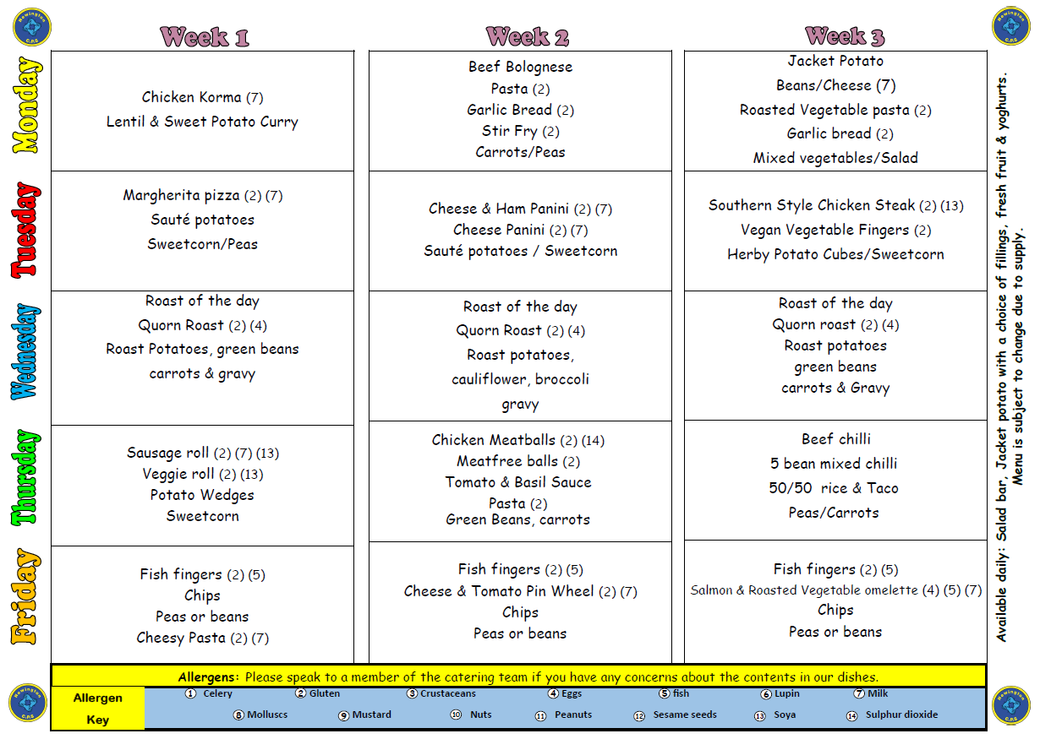
What’s for pudding?
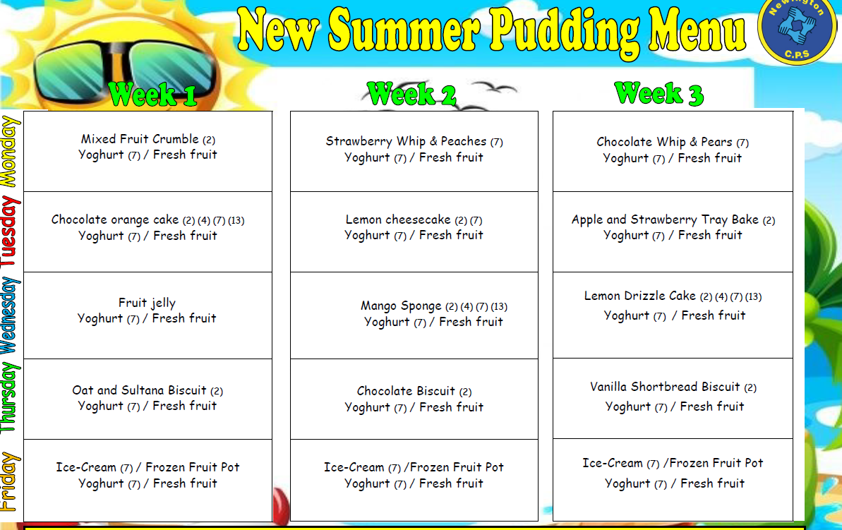
Snacks and Water
Children in Reception and KS 1 do not need to bring a snack to school. Snacks in these year groups are covered by the Fruit and Vegetable Scheme and the school is an active member of this scheme. Children in Years N – 2 are provided with a wide range of fruit and vegetable snacks each day and these are delivered to the classrooms by some of our wonderful Year 6 children.
Children in Years 3 – 6 can bring snacks to school, however the school has a clear policy on snacks and we ask all families to respect this policy. Agreed snacks are: any fruit or vegetable, yoghurt, fruit based snacks (Winders, Fruit Flakes or Raisins), Rice Cakes. Crisps, biscuits and chocolate are not to be brought in to school as snacks.
There is fresh drinking water accessible to all children throughout the school. Children must bring a named water bottle to school each day to ensure that water is easily available.
We are looking forward to a great start to Term 1 – the teachers are ready, the school is looking amazing and we have been eagerly waiting to meet our new Reception starters – what an adventure they will have! I will send another newsletter very soon with some early celebrations to share with you all.

With very best wishes

Hannah Tudor and Team Newington!

