
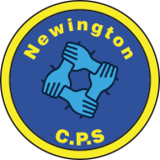
Dds
Ambition, Achievement, Aspiration
Newington Community Primary School
Princess Margaret Avenue, Ramsgate, Kent. CT12 6HX
Tel: (01843) 593412 Fax: (01843) 850323
Headteacher: Miss Hannah Tudor
E-mail: headteacher@newington-ramsgate.kent.sch.uk

Friday 18th September 2026

Dear Parents and Carers

Wow – what a start to the year we have had! We have already fitted so much in to the first two weeks of term. I wanted to share some of the things happening in school that we are really proud of.

This Term’s Core Value – RESPECT

This term the whole school is focusing on our core value of RESPECT. We summarise respect at Newington using this quote:
“Respect is a two-way street, if you want to get it, you’ve got to give it”

All children will be considering a key aspect of our value from understanding how to look after nature and the world around us, using “please” and “thank you” and showing good manners to behaving respectfully online. All staff know the importance of modelling respect to all of our children and expecting it in return. As part of their learning, Year 1 created self-portraits, Year 2 made friendship bracelets and gifted them to people in their class, Year 3 shared the story “The Proudest Blue” and learnt about respecting other peoples’ cultural identities. Year 4 created music linked to the environment and shared the story “The Window” as a year group. Year 5 and 6 both learnt about being respectful online, thinking about what we post and how we comment. They wrote “Class Charters” for staying safe online and focused on the “dos and dont’s” when using “WhatsApp” group chats.

These are the books we used to inspire our learning.

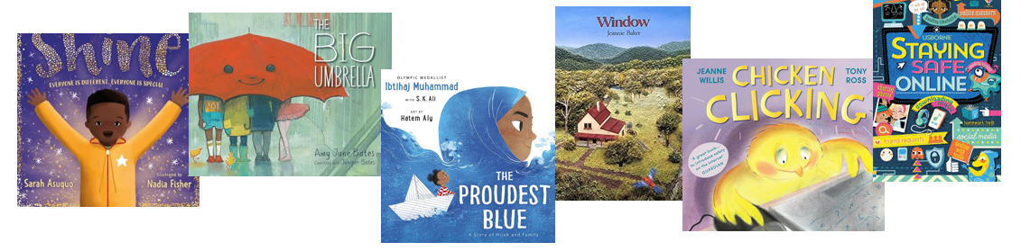

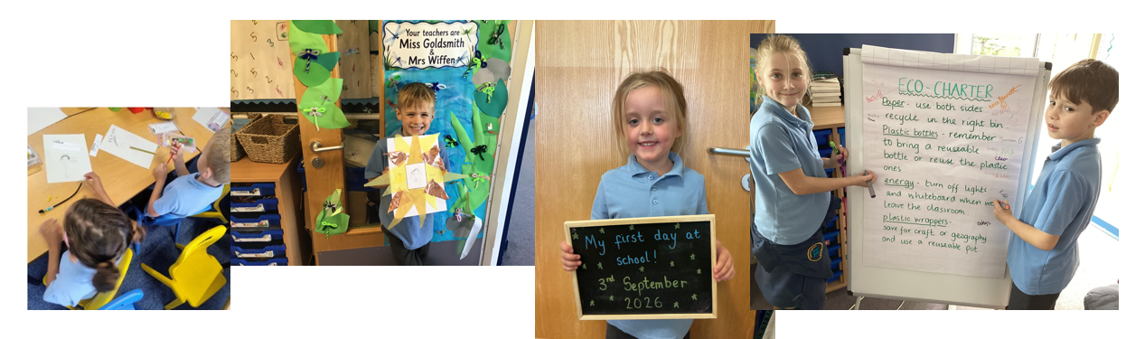

Just keep swimming!

We are so proud of being able to bring provision for swimming on site for our children. Working in partnership with Swim:ED has made such a huge impact to our children already. Lessons are taking place throughout the day. The children are taught in smaller groups to ensure that they have the focused instruction that they need and great use of assessment means that the children progress QUICKLY, gaining confidence as they follow each instruction. It really is impressive to watch. Thank you to all parents who came to look round the new pool on the first couple of days of term.



The Building!

The school building has been in desperate need of some love and attention and now, it is getting a full makeover, thanks to our amazing site team! The summer brought with it a LOT of work to the inside of the building, starting off with a phased redecoration project so that all of the children have inviting classrooms to learn in.
Here are some photos of some of the updates that have been happening inside our school!

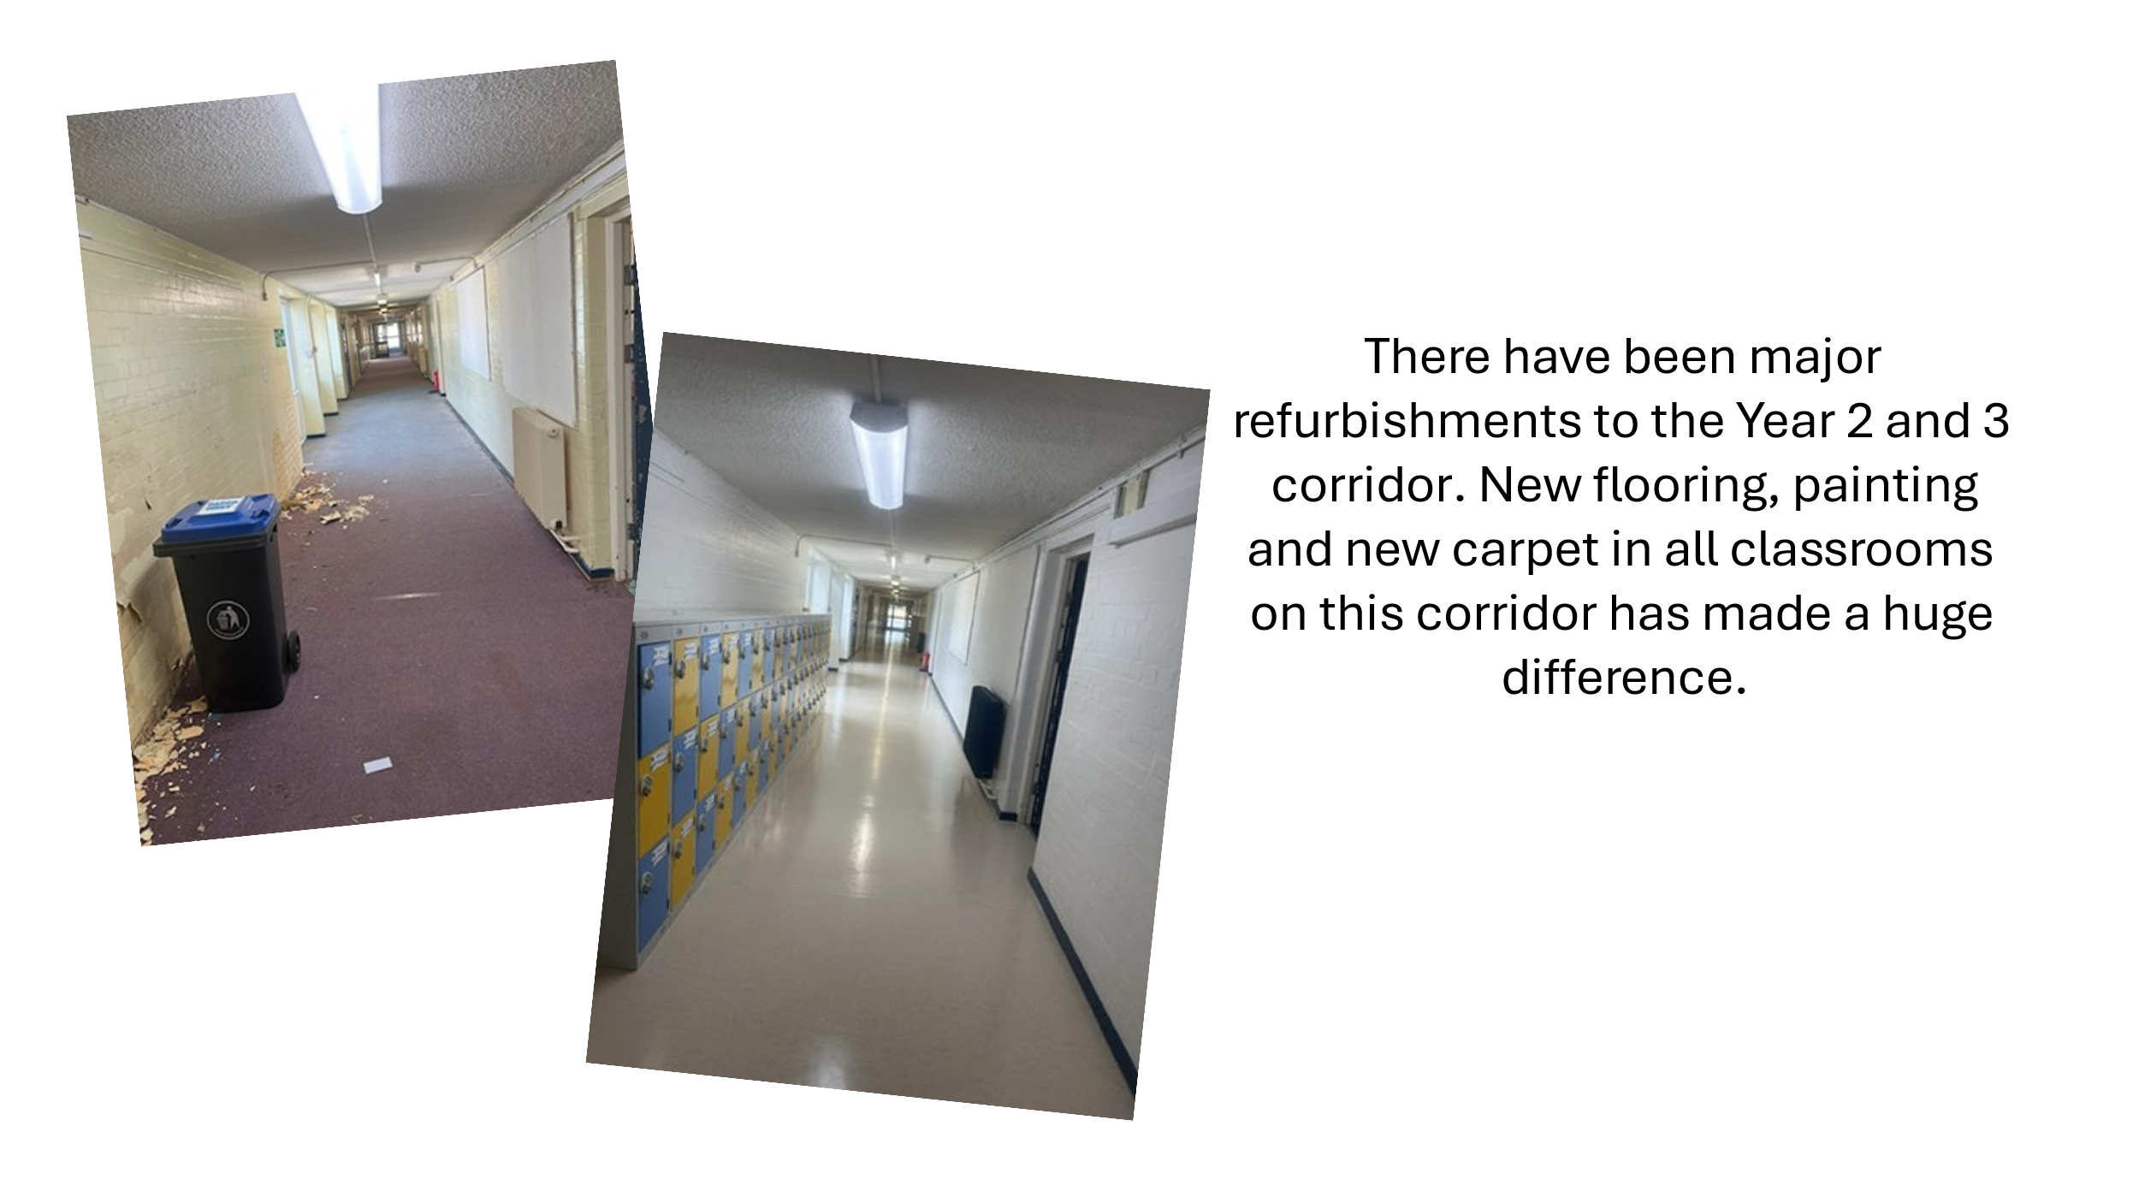
New Snazzy Toilets

We wouldn’t normally share pictures of toilets on the newsletter but…..look at these!! Full refurbishment of 2 of our toilet blocks over the summer has given the children in Key Stage 2 someone much nicer to go to the loo! (Of course, they are blue and yellow!!). The children are really looking after them too! The remaining blocks will be refurbished at the end of this school year.

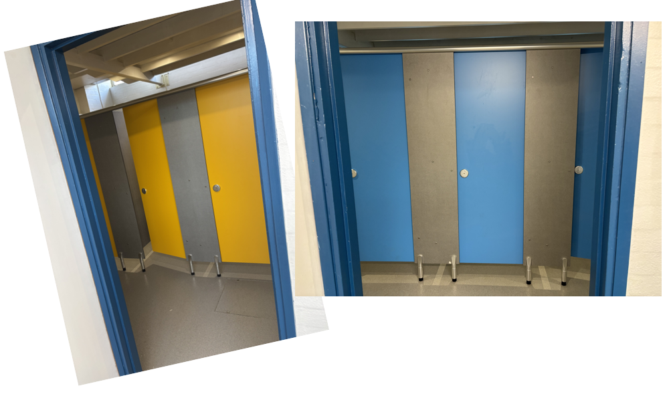

Alongside this, our amazing site team have also used 40l of floor polish, laid 340 sqm of carpet tiles, cut 3km of hedge, built a new art storage room and disposed of 7600 cubic metres of waste!!! No heroes wear capes!

Meet the Teacher Events

Thank you to all parents and families who have attended our Meet the Teacher events, starting this week. Years 4, 5 and 6 had a wonderful time meeting with all of our families and it was a pleasure to see the children showing their families their new classrooms. Meet the Teacher events will take place next week for Year 3 (Monday), Year 2 (Tuesday), Year R (Wednesday) and Year 1 (Thursday). Looking forward to seeing you there!

Benedict’s Law – Allergy Awareness

The school have reviewed all of their provision in line with Benedict’s Law and all staff are fully trained to support children who have allergies in school. A reminder to all of our families that food items should not be brought in to school to celebrate birthdays. Non food items such as stickers, are completely acceptable but children should not be bringing in cakes, sweets or other food items. Many thanks for your understanding.
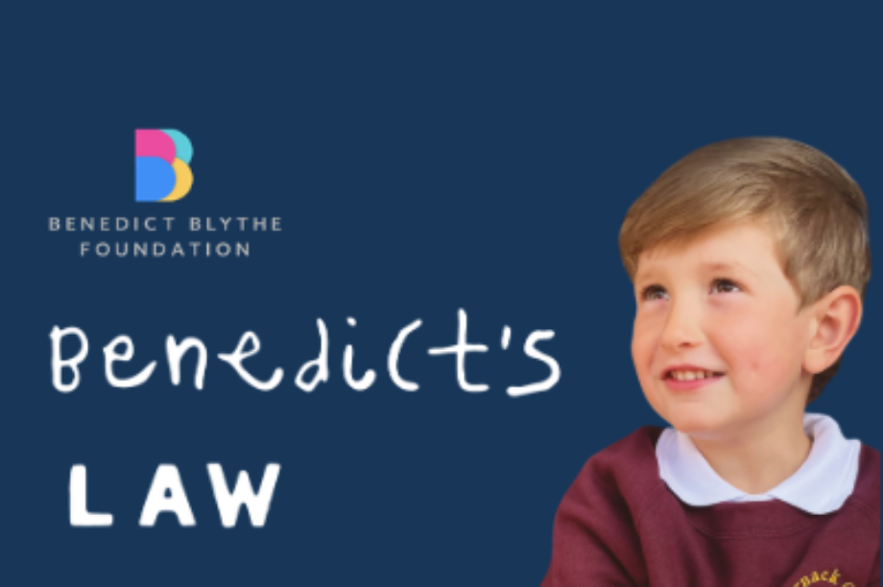

What’s for Lunch?
Please see this term’s lunch menu. We will start on Week 1.
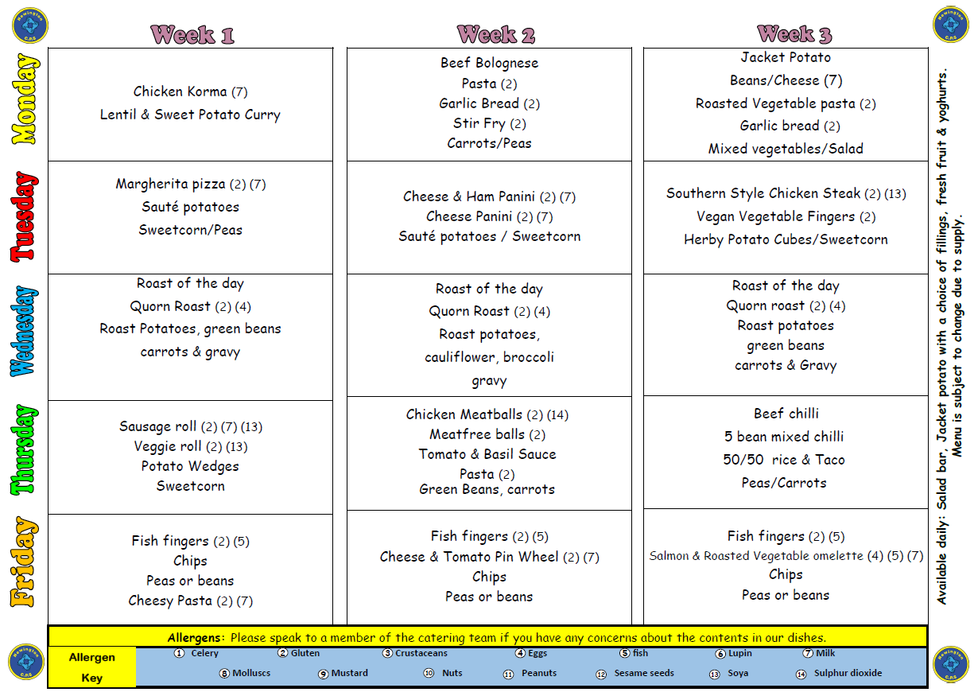

What’s for pudding?
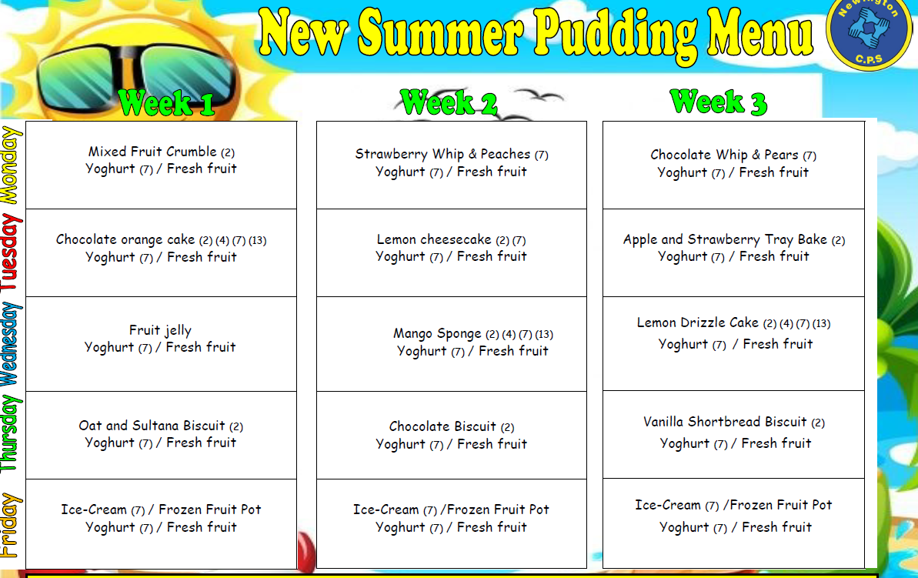
Snacks and Water
Children in Reception and KS 1 do not need to bring a snack to school. Snacks in these year groups are covered by the Fruit and Vegetable Scheme and the school is an active member of this scheme. Children in Years N – 2 are provided with a wide range of fruit and vegetable snacks each day and these are delivered to the classrooms by some of our wonderful Year 6 children.
Children in Years 3 – 6 can bring snacks to school, however the school has a clear policy on snacks and we ask all families to respect this policy. Agreed snacks are: any fruit or vegetable, yoghurt, fruit based snacks (Winders, Fruit Flakes or Raisins), Rice Cakes. Crisps, biscuits and chocolate are not to be brought in to school as snacks.
There is fresh drinking water accessible to all children throughout the school. Children must bring a named water bottle to school each day to ensure that water is easily available.
What a great start to the year! We couldn’t have asked for better!

With very best wishes

Hannah Tudor and Team Newington!

